Geo Spacial Matching for Image Retrieval.

INDEX
1. Introduction
2. System Analysis
a. Existing System
b. proposed System
3. Feasibility Report
a. Technical Feasibility
b. Operational Feasibility
c. Economical Feasibility
4. System Requirement Specification Document
a. Overview
b. Modules Description
c. Process Flow
d. SDLC Methodology
e. Software Requirements
f. Hardware Requirements
5. System Design
a. DFD
b. E-R diagram
c. UML
d. Data Dictionary
6. Technology Description
7. Coding
8. Testing & Debugging Techniques
9. Output Screens
10. Reports
11. Future Enhancements
12. Bibliography

INTRODUCTION

Abstract
Project name: Geo Spacial Matching for Image Retrieval.
Every day the average person with a computer faces a growing flow of multimedia information particularly via the Internet. But this ocean of information would be useless without the ability to manipulate, classify, archive and access them quickly and selectively. While text indexing is ubiquitous, it is often limited, tedious and subjective for describing image content.
One of the main problems was the difficulty of locating the desired image in a large and varied collection, while it is perfectly feasible to identify the desired image from a small collection simply by browsing. More effective techniques are needed with collections containing thousands of items.
CONVENTIONAL TECHNIQUES (TEXT ANNOTATION):
To date, image and video storage and retrieval systems have typically relied on human supplied textual annotations to enable indexing and searches. The text-based indexes for large image and video archives are time consuming to create. They necessitate that each image and video scene is analyzed manually by a domain expert so the contents can be described textually. The language-based descriptions, however, can never capture the visual content sufficiently.
For example, a description of the overall semantic content of an image does not include an enumeration of all the objects and their characteristics, which may be of interest later. A content mismatch occurs when the information that the domain expert ascertains from an image differs from the information that the user is interested in. A content mismatch is catastrophic in the sense that little can be done to approximate or recover the omitted annotations. In addition, a language mismatch can occur when the user and the domain expert use different languages or phrases. Because text-based matching provides only hit-or-miss type searching, when the user does not specify the right keywords the desired images are unreachable without examining the entire collection.
CONTENT BASED RETRIEVAL:
The problems with text-based access to images have prompted increasing interest in the development of image based solutions. This is more often referred to as Content Based Image Retrieval (CBIR). Content Based Image Retrieval relies on the characterization of primitive features such as colour, shape and texture that can be automatically extracted from the images themselves.
Queries to CBIR system are most often expressed as visual exemplars of the type of the image or image attributed being sought. For Example user may submit a sketch, click on the texture pallet, or select a particular shape of interest. This system then identifies those stored images with a high degree of similarity to the requested feature.

SYSTEM ANALYSIS

EXISTING SYSTEMS:
IBM’s QBIC system is the first commercial CBIR system and probably the best known of all CBIR systems. QBIC supports users to retrieval images by colour, shape and texture. QBIC provides several query methods: Simple, Multi-feature and Multi-pass. In the simple method, a query is processed using only one feature. A Multi-feature query involves more than one feature and all features have equal weights during the search. A Multi-pass query uses the output of a previous query as the basis for further refinements. Users can draw and specify colour and texture colour and texture patterns in desired images. In QBIC, the colour similarity is computed by quadratic metric using k-element colour histograms and the average colours are used as filters to improve query efficiency. Its shape function retrieves images by shape area, circularity, eccentricity and major axis orientation. Its texture function retrieves images by global coarseness, contrast and directionality features.
The Photo book system (developed at the Massachusetts institute of technology) allows retrieving images by colour, shape and texture features. This system provides a set of matching algorithms, including Euclidean, mahalanobis, divergence, vector space angle, histogram, Fourier peak, and wavelet tree distances as distance metrics. In its most recent version, users can define their own matching algorithms.
The Imatch system allows users to retrieve images by colour, texture and shape. Imatch supports several query similar images: Colour similarity, colour and shape (Quick), colour and Shape (Fuzzy), and colour distribution.

PROPOSED SYSTEM:
Currently the most widely used image search engine, the GOOGLE, provides its users with the textual annotation kind of implementation. With lacks of images added to the image database, not many images are annotated with proper description. So many relevant images go unmatched.
The most widely accepted content-based image retrieval techniques use the Quadratic Distance and the Integrated Region Matching methods. The Quadratic Distance method, though yields metric distance, is computationally expensive. The conventional Integrated Region Matching is non-metric and hence gives results that are not optimal. Our system uses a modified IRM method which overcomes the disadvantages of both the above mentioned methods. The color feature is extracted using the commonly adopted histogram technique.
We also provide an interface where the user can give a query image as an input. The colour feature is automatically extracted from the query image and is compared to the images in the database retrieving the matching images.

FEASIBILITY REPORT

Fact Finding Techniques
In this system we are going to develop a facility to a user that he will not face any difficulty at the time of usage like data missing, one way contacts, one view contacts. As we are developing this system with an encoding technique of images the user will not be bothered on which camera support is using, as well in sound. As we are maintaining one technique of speed controlling the frame relay will not be a problem for the user like over speed display, hanged display.

Feasibility Study
A feasibility study is a high-level capsule version of the entire System analysis and Design Process. The study begins by classifying the problem definition. Feasibility is to determine if it’s worth doing. Once an acceptance problem definition has been generated, the analyst develops a logical model of the system. A search for alternatives is analyzed carefully. There are 3 parts in feasibility study.
Operational Feasibility:
Question that going to be asked are
- Will the system be used if it developed and implemented.
- If there was sufficient support for the project from the management and from the users.
- Have the users been involved in planning and development of the
Project.
- Will the system produce poorer result in any respect or area?
This system can be implemented in the organization because there is adequate support from management and users. Being developed in Java so that the necessary operations are carried out automatically.

Technical feasibility
- Does the necessary technology exist to do what is been suggested
- Does the proposed equipment have the technical capacity for using the new system?
- Are there technical guarantees of accuracy, reliability and data security?
- The project is developed on Pentium IV with 256 MB RAM.
- The environment required in the development of system is any windows platform
- The observer pattern along with factory pattern will update the results eventually
- The language used in the development is JAVA 1.5 & Windows Environment

Financial and Economical Feasibility:
The system developed and installed will be good benefit to the organization. The system will be developed and operated in the existing hardware and software infrastructure. So there is no need of additional hardware and software for the system.

SYSTEM REQUIREMENT SPECIFICATION

Content-based image retrieval is one of the techniques for automatic retrieval of images from a database by colour, texture and shape features. The features used for retrieval can be either primitive or semantic but the abstraction process must be predominantly automatic.
The goal of Content-Based Image Retrieval (CBIR) systems is to operate on collections of images and, in response to visual queries, extract relevant image. The application potential of CBIR for fast and effective image retrieval is enormous, expanding the use of computer technology to a management tool.
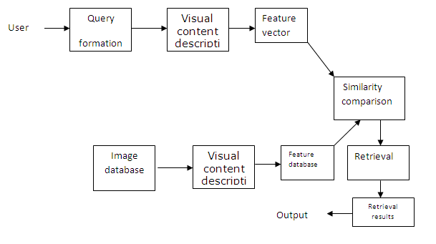

Diagram for content based image retrieval system

CLASSIFICATION OF CBIR SYSTEMS
Existing CBIR systems based on low-level visual features can be classified into three main categories. They are

- Global approaches
- Partition-based approaches
- Regional approaches

Global approaches
Global approaches describe the visual content of an image as whole without spatial or topological information. Several features have been used to represent images in CBIR systems. The most commonly used feature is colour. Global colour histogram is an example for this. It is simple and effective way of utilizing the colour features. The GCH is an n-dimensional vector C = {c(1),c(2),……..c(n)) where each element C_{J} represents the percentage of pixels of colours J in an image.
Partition based approaches:
Partition based approaches introduce some spatial information about the visual content of images, decomposing them in spatial cells, according to a fixed scheme and describing the content of each cell individually.
An example for this is the local colour histograms. An image is portioned into equal sized sub images/blocks and the similarity between two images is based on the histogram distances between corresponding blocks.

Disadvantages

1. It is not capable of handling geometric transformations like rotation and translation.
2. Problems like variance to absolute spatial location.

Regional approaches

Regional approaches in the sense that instead of decomposing images in a fixed way, these approaches exploit their visual content to achieve a more flexible and robust segmentation. Unlike partition cells, segmented regions of two distinct images may have different size, position and shape. Moreover the number of two images may be different.

3.3 CURRENT CBIR APPROACHES

CBIR operates on the principle of retrieving stored images from a collection by comparing features automatically extracted from the images themselves. The commonest features used are mathematical measures of colour, texture or shape. A typical system allows users to formulate queries by submitting an example of the type of image being sought, though some offer alternatives such as selection from a palette or sketch input. The system then identifies those stored images whose feature values match those of the query most closely, and displays thumbnails of these images on the screen.
Domain specific features:
Visual features
- Fingerprints, Human faces

General features:
- Colour, texture, shape

Some of the most commonly used types of features used for image retrieval are as follows

Colour retrieval

Several methods for retrieving images on the basis of colour similarity have been described in the literature, but most are variations on the same basic idea. Each image added to the collection is analysed to compute a colour histogram, which shows the proportion of pixels of each colour within the image. The colour histogram for each image is then stores in then stored in the database. At each time, the user can either specify the desired proportion of each colour (&75% olive green and 25% red, for example), or submit an example image from which a colour histogram is calculated. Either way, the matching process then retrieves those, which a colour histogram is calculated. Either way, the matching process then retrieves those images whose colour histograms match those of the query most closely.

Texture retrieval:
The ability to match on texture similarity can often be useful in distinguishing between areas of images with similar colour (such as blue sky and sea or green leaves and grass). A variety of techniques has been used for measuring texture similarity; the best established rely on comparing values of what are known as second-order statistics calculated from query and stored images. Essentially, these calculate the relative brightness of selected pairs of pixels from each image. From these it is possible to calculate measures of image texture such as the degree of contrast, coarseness, directionality and regularity or periodically, directionality and randomness.
Texture queries can be formulated in a similar manner to colour queries, by selecting examples of desires texture a palette, or by supplying an example query image. The system then retrieves images with texture measures most similar in value to the query.

Shape retrieval:
Two major steps are involves in shape feature extraction. They are object segmentation and shape representation.
Object segmentation: Segmentation is very important to Image Retrieval. Both the shape feature and the layout feature depend on good segmentation allow fast and efficient searching for information of a user’s need.
Shape representation: In image retrieval, depending on the applications, some requires the shape representation to be invariant to translation, rotation, and scaling. In general, the shape representations can be divided into two categories, boundary-based and region-based. The former uses only the outer boundary of the shape while the latter uses the entire shape region.

REQUIREMENTS FOR CBIR SYSTEMS:
The following three elements are important for building a CBIR system.
Techniques to automatically extract metadata containing primitive features of images:
The metadata depict images with primitive features. Each primitive feature has its own representation format, such as the colour histogram, and has been widely used to represent the colour feature. Another example is the shape feature, which can be represented by sets of consecutive boundary segments. With the appropriate metadata, current CBIR systems can achieve retrieval by colour, texture, by shape and spatial relationship.
Interfaces to obtain the users’ query demands:
The retrieval process begins with a query requirement. Hence, it crucial to capture the users’ query to capture the users’ query demands accurately and easily. Query by text has been widely used in retrieval systems – for example searching for desired book with keyword in a library. For current CBIR systems, the image retrieval process is usually carried out through an example image provided by the user, called query-by-example. However, users cannot always submit an example image to the retrieval system. Typically, current CBIR systems solve this problem by offering submit an example image to the retrieval system.
For instance, users can specify the colour feature query by choosing relative amounts of red, green, and blue or by selecting a desired colour from a colour palette. Also, users can choose the desired texture for the texture feature query and draw a sketch for the shape feature query. Sometimes when querying by example image, we are not interested in whole image but just some parts or objects. Also, we may not be concerned about the location of objects. For instance, in the case of an image of Green Mountain with a sunrise, we might want to retrieve images with only a sunrise. We do not care whether the sunrise is over a green mountain or a blue sea and we do not care whether the sunrise is on the left top of the image or in the right middle of the image. In other words, the process involves sub-image or object retrieval. Given an example image, we choose a significant part, and the CBIR system searches for the desired images that contain the part similar to the part in the sample image.
Methods to compare the similarities (or differences) between images
CBIR systems require methods that are based on the primitive features to compare the similarities or differences between an example image and all the images in the image collection. However, the similarities or differences between images cannot be qualified in an ideal manner. The extent to which the images are similar will change when query requirements are varied. For instance, in the case of two pictures, one of a blue sea with a sunrise and the other of a green mountain with a sunrise, when the sunrise is considered the similarity between the two images is low. We believe that it would be very difficult to find a method to measure the similarities or differences between images accurately for all kinds of query demands. In other words, every retrieval method will have its own limits. For example, it will be hard for a colour based image retrieval technology to differentiate an image of blue sky from an image of blue sea. Therefore when evaluating a CBIR technology, one should remember that the retrieval effectiveness of that technology depends on the types of query requirements that users make.

PRACTICAL APPLICATIONS OF CBIR:

A wide range of possible applications for CBIR technology are
Crime prevention: Law enforcement agencies typically maintain large archives of visual evidence including past suspects facial photographs, fingerprints and shoe prints. Whenever a serious crime is committed, they can compare evidence from the scene of the crime for its similarity to records in their archives.

Military: Recognition of enemy aircraft from radar screens, identification of targets from satellite photographs, and provision of guidance systems for cruise missiles are some of the examples in military field.
Intellectual property: Trademark image registration, where a new mark is compared with existing marks to ensure that there is no risk of confusion, has long been recognized as a prime application area for CBIR. Copyright protection is also a potentially important application area.
Architecture and engineering design: Architectural and engineering design share a number of common features- the use of stylized 2-D and 3-D models to represent design objects, the need to visualize designs for the benefit of non-technical clients and the need to work within externally-imposed constraints, often financial. Such constraints mean that the designer needs to be aware of previous designer needs to aware of previous designs, particularly if these can be adapted to the problem at hand.
Fashion and interior design: Similarities can be observed in the design process in other fields, including fashion and interior design. Here again the designer has to work within externally imposed constraints, such as choice of materials. The ability to search a collection of fabrics to find a particular combination of colour or texture is increasingly being recognized as a useful aid to the design process.
Journalism and advertising: Both newspapers and stock shot agencies maintain archives of still photographs to illustrate articles or advertising copy. These archives can often be extremely large (running into millions of images), and dauntingly expensive to maintain if detailed keyword indexing is provided. Hence CBIR techniques are very useful here.
Medical diagnosis: The increasing reliance of modern medicine on diagnostic techniques such as radiology, histopathology, and computerized tomography has resulted in am explosion in the number and importance of medical images now stored by most hospitals. While the prime requirement for medical imaging systems is to be able to display images relating to a named patient, there is increasing interest in the use of CBIR techniques to aid diagnosis by identifying similar past cases.
Geographical information and remote sensing systems: Agriculturalists and physical geographers use images (searching by spatial attribute) extensively, both in research and for more practical purposes, such as identifying areas where crops are diseased or lacking in nutrients- or alerting governments to farmers growing crops on land they have paid to leave lying fallow.
Education and training: The availability of searchable collections of video clips providing examples of avalanches for a lecture on mountain safety, or traffic congestion for a course on urban planning, could reduce preparation time and lead to improve teaching quality. In some cases such videos might even replace a human tutor.
Home entertainment: Much home entertainment is image or video-based, including holiday snapshots, home videos and scenes from favorite TV programmers or films. Possible applications could include management of family photo albums.

Histogram Similarity distance approach

The human eye is sensitive to colors, and color features are one of the most important elements enabling humans to recognize images. Color features are, therefore, fundamental characteristics of the content of images. Color features can most often provide powerful information for categorizing images, and they are very useful for image retrieval. Therefore, color based image is widely used in CBIR systems.

Color histograms are generally used to represent the color features of images. Before using color histograms, however, we need to select and quantify a color space model and choose a distance metric.
COLOR SPACE:
A color space is defined as a model for representing color in terms of intensity values. The color space models can be different as hardware-oriented and user-oriented. The hardware-oriented color spaces, including RGB, CMY, and YIQ, are based on the three-color stimuli theory. The user-oriented color spaces, including HLS, HCV, HSV and HSB, are based on the three human percepts of colors, i.e., hue, saturation, and brightness. The color space can also be distinguished as uniform and non-uniform depending in differences in color space as perceived by humans.
RGB color model:
The RGB color space is defined as a unit cube with Red, Green and Blue axes; hence a color in an RGB color space is represented by a vector with three Co-ordinates. When all three values are set to zero, the corresponding color is Black. When all three values are set to one, the corresponding color is white.
The RGB model uses the Cartesian coordinate system as shown in Figure (a). Notice the diagonal from (0,0,0) black to (1,1,1) white which represents the grey-scale. Figure (b) is a view of the RGB color model looking down from "White" to origin. Commonly used image formats such as JPEG’s, GIF’s and BMP’s always store and show colors in RGB color space. For current computer systems, the RGB color space is usually represented by a 24 bit true color system. In a 24 bit color system a color is specified by 3 integers: (red, green and blue), and these 3 integers range from 0 to 28-1 respectively, so giving 16,777,216 (224) colors in total.
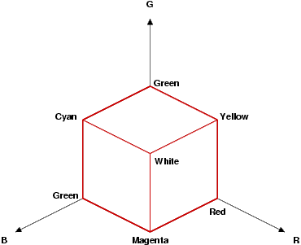
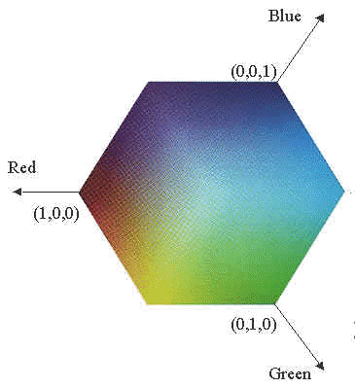

(a) RGB coordinates system (b) RGB color model
Figure 6
HISTOGRAMS :
The histogram expresses the frequency distribution of the grey levels with in an image. This is a chart that shows how many of the pixels in an image have each level of luminosity (brightness) from black (0) to white (255). The portion of the histogram that is to the left shows how much of your image is dark (black or nearly black), while the part to the right shows the amount of the image that is light (white or nearly white).
In an image processing context, the histogram of an image normally refers to a histogram of the pixel intensity values. This histogram is a graph showing the number of pixels in an image at each different intensity value found in that image. For an 8-bit grayscale image there are 256 different possible intensities, and so the histogram will graphically display 256 numbers showing the distribution of pixels amongst those grayscale values. Histograms can also be taken of color images, either individual histograms of red, green and blue channels can be taken, or a 3-D histogram can be produced, with the three axes representing the red, blue and green channels, and brightness at each point representing the pixel count. The exact output from the operation depends upon the implementation.
If the curve of the histogram appears pushed to the left, your image is mostly dark, and if it is pushed to the right, then, likewise, it is mostly light. It is important to realize that this doesn't automatically mean that the photo is under- or over- exposed. You need to decide if this is the way that you wanted to capture the scene. If you are looking at a bright scene, it would probably make sense for the histogram to be pushed toward the right, but if it is meant to be a dark and moody scene, then the same histogram would indicate that it is overexposed. You could then adjust your camera's settings in order to compensate.
One very important thing to watch for is whether the histogram has a spike all the way against the far left or far right edge. Such a histogram shows that you have a lot of pixels that are pure black or pure white with no detail. Unless you really want large areas of pure white or black, it means that your image is over- or underexposed. If your histogram has a nice smooth hump in the middle, then the image is in the mid tone range and your camera should have little trouble in capturing it.
TRADITIONAL COLOR BASED HISTOGRAM SIMILARITY DISTANCE TECHNIQUES
There are two traditional techniques for color based image retrieval:
Global Color Histograms Local Color Histograms
Global color histograms:
Global color histograms represent the images with single histograms. The color histogram depicts color distribution using a set of bins. Using Global Color Histograms, an image will be encoded with its color histogram, and the distance between two images will be determined by the distance between their color histograms.
Local color histograms
Local Color Histograms divides the images into fixed blocks and for each block obtain its histogram. This approach includes information concerning the color distribution of regions. The first step is to segment the image into blocks and then obtain a color histogram for each block. An image will then be represented by using these histograms. When comparing two images, we calculate the distance, using their histograms, between a region in one image and a region in same location in the other image. The distance between the two images will be determined by the sum of all these distances.
HOW TO READ A HISTOGRAM
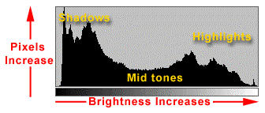
- The horizontal axis represents the range of brightness from 0 (shadows) on the left to 255 (highlights) on the right. Think of it as a line with 256 spaces on which to stack pixels of the same brightness. Since these are the only values that can be captured by the camera, the horizontal line also represents the camera's maximum potential dynamic range.

- The vertical axis represents the number of pixels that have each one of the 256 brightness values. The higher the line coming up from the horizontal axis, the more pixels there are at that level of brightness.
To read the histogram, you look at the distribution of pixels. An image that uses the entire dynamic range of the camera will have a reasonable number of pixels at every level of brightness. An image that has low contrast will have the pixels clumped together and have a narrower dynamic range.
THE HISTOGRAM BASED IMAGE RETRIEVAL
The color histogram for an image is constructed by counting the number of pixels of each color. In these studies the developments of the extraction algorithms follow a similar progression:
(1) Selection of a color space
(2) Quantization of the color space
(3) Computation of histograms
(4) Derivation of the histogram distance function
(5) Identification of indexing shortcuts.
Each of these steps may be crucial towards developing a successful algorithm. But there has been no consensus about what are the best choices for these parameters.

ADVANTAGE OF USING HISTOGRAM:
The advantage of using the histogram of the image is that it is totally independent of the distribution of the pixels, thus also independent of the distribution of the stars in the image, if one ignores crowding effects. The crowding should be dealt with in an appropriate way, e.g. by assuming that the stars are placed randomly throughout the image, or have a certain gradient in star density over the image.

SAMPLE HISTOGRAMS:
HISTOGRAM QUADRATIC DISTANCE MEASURES
 | 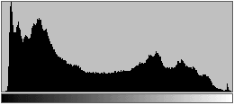
In this typical well exposed portrait there is a fairly even distribution of values in both the shadow and highlight areas of the image. One thing you can see immediately from the histogram is that there are no pure blacks in the image. This is shown by the gap at the far left end of the scale.
To address the shortcomings of Minkowski-form metrics in comparing only "like" bins, quadratic-form metrics consider the cross-relation of the bins. As shown in Figure. The quadratic-form metrics compare all bins and weight the inter-element distance by pair wise weighting factors.

Histogram quadratic distance measures (d4):
The IBM QBIC system developed a quadratic-form metric for color histogram-based image retrieval, reports that the quadratic-form metric between color histograms provides more desirable results than "like-color''-only comparisons. The quadratic-form distance between color histograms hq and ht (is given by:
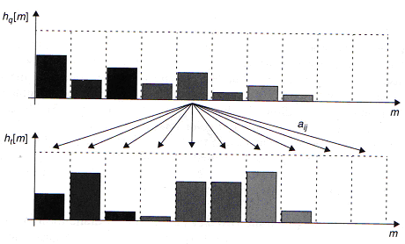

Quadratic-form metrics compare multiple bins between the color histogram using a similarity matrix A = [aij], which can take into account color similarity or color Covariance.
Disadvantages of histogram quadratic distance measures
It has the advantage of yielding optimal results because of it is metric distance. Commercially it is never used for similarity based image retrieval because it is computationally very expensive.

True IRM

WHY INTEGRATED REGION MATCHING?
IRM incorporates the properties of all segmented regions so that the information about an image can be fully used. Region-Based matching is a difficult problem because of inaccurate segmentation. Semantically precise image segmentation is extremely difficult and is still an open problem in computer vision. For example, segmentation algorithm can segment a dog into two regions: the dog and the background. The same algorithm may segment another image of a dog into six regions: the body of the dog, the front legs of the dog, the rear legs, the eyes, the background grass and the sky
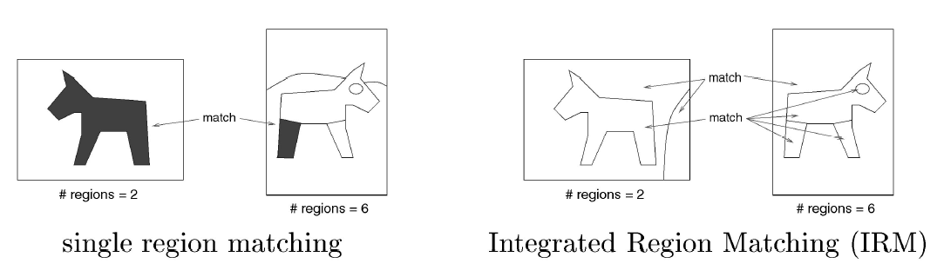
The IRM measure has the following major advantages:
- Compared with retrieval based on individual regions the overall similarity approach in IRM reduces the adverse effect of inaccurate segmentation, an important property that previous works have virtually overlooked
- In many cases, knowing that one object usually appears with another object helps to clarify the semantics of a particular region.
- By defining an overall image to image similarity measure, the system provides the users with a simple querying interface. To complete a query, a user only needs to specify the query image. If desired, the system can also be adjusted to allow users to query-based on a specific region or a few regions.
To define the similarity measure, a first attempt to match region in two images. Being aware that segmentation cannot be perfect, the IRM softens the matching by allowing one region of an image to be matched to several regions of another image. Here, a region to region match is obtained when the regions are relatively similar to each other in terms of the features extracted.
The principle of matching is that the closest region pair is matched first. This matching scheme is called the Integrated Region Matching (IRM) to stress the incorporation of regions in the retrieval process. After regions are matched, the similarity measure is computed as a weighted sum of the similarity between region pairs, with weights determined by the matching scheme.
COMPARISON OF HISTOGRAMS OF IMAGES
One important aspect of any CBIR system is the distance used to compare the visual features extracted from the images. Such a distance affects directly the time spent to processing a visual query and the quality of the retrieval (effectiveness). The better the distance simulates the human perception of similarity using the available visual features, the more effective is the CBIR system in retrieving relevant images to the user’s need. The computational complexity of the distance is another important issue when processing a visual query. Depending on the distance complexity, the time to compute the distance between images must be superior to the time to access the disk pages where the visual features are stored.
Let h and g represent two color histograms. The Euclidean distance between the color histograms h and g can be computed as:
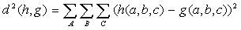
In this distance formula, there is only comparison between the identical bins in the respective histograms. Two different bins may represent perceptually similar colors but are not compared cross-wise. All bins contribute equally to the distance.
Unfortunately, regional CBIR approaches cannot be adequately modeled in a vectorial space, because the number of regions of two images may be different and the obtained regions may also have different sizes. As a consequence, the comparison of images is usually based on complex distance functions.
Regional CBIR approaches are better modeled in a metric space. A metric space is composed by a set of elements (in our case, these elements are visual features) and a metric distance to compare these elements. In metric spaces, there are no restrictions about the representation of visual features. In this case, what really matter are the metric properties of the distance used to compare the visual features. A distance d is considered a metric if, for any (images) X, Y and Z, the following properties hold:
Positive ness or Minimality: d(X, Y) >= 0
Symmetry: d(X, Y) = d(Y, X)
Reflexivity or Self-similarity: d(X, X) = 0
Triangular Inequality: d(X, Z) <= d(X, Y) + d(Y,Z)
Metric spaces can be efficiently indexed using metric access methods (MAMs). These methods make extensive use of triangular inequality property to reduce the search space and also the number of distance computations at query time.
The main problem to model a regional CBIR approach in metric space is related to the distance used to compare segmented images.
OUR True IRM
The distance irm(X, Y) between two images X and Y is algorithmically described below, and works as follows. Initially, all distances dhist(Xi, Yj) between the pairs of levels are computed , checked for the monge condition, and ordered. Additionally, all levels are initialized as “non-matched” (status = 0). The distance dhist(Xi, Yj) depends on the visual features extracted from the levels. In our case it is weighted composition of the distance between the histogram levels and the distance between the sizes of the levels (bins).
After ordering the distances, the first value corresponds to the best possible match between a level of image X and a level of image Y. The second value corresponds to the second best match and so on. For each distance dhist(Xi, Yj) in a non-decreasing order, if both levels are marked as non-matched,and check the monge condition, the size of levels Xi and Xj are compared. The size of the smallest level determines the weight w that multiplies the values dhist(Xi, Yj) in order to obtain the final distance between the images (β). This weight represents to percentage of matching between the two images with that distance.
In each iteration of the for loop, the smallest level is marked as “matched” (status =1). This means that the full content of the level was matched. Thus, any other distance

1
2
3
4
1
2
3
4
0.2
0.3
0.4
0.1
0.2
0.2
0.3
0.2
0 - 0.2
0 - 0.2
0 - 0.3
0 - 0.1
2 - 0.1
1 - 0.1

related to this level in the next iterations should be discarded. Since at each iteration, the largest region may not be completely matched, we subtract the size of the smallest level (the percentage of level actually matched) from the size of the largest one. After this operation, if the size of the level equals zero (occurs when the two compared levels have the same size), both levels are marked as matched. If the size of the largest level remains greater than zero, then we continue analyzing distances involving this level until its size equals zero. Observe that, at the end of the process, the sum of the weighted values w equals 1, meaning that the entire image content was compared.
Monge condition:
Hoffman proved that ,if distance matrix satisfies the monge condition,then greedy approach gives optimal solution.
Our histogram distance matrix implicitly satisfies the monge condition. Hence our approach gives optimal solution , that is metric distance. So we called our modified IRM, True IRM.
Our True IRM algorithm
IRM(X,Y)
FOR EACH PAIR OF HISTOGRAM LEVELS Xi Є X and Yi Є Y
Xi.status = Yj.status = 0
Compute Dhist(Xi,Yj) and check the monge condition
β = 0
counter=2n-1
FOR EACH Dhist (Xi,Yj) IN A NON-DECREASING ORDER
if Xi.status = Yj.status = 0
if Xi.size < Yj.size
w=Xi.size
Yj.size = Yj.size-Xi.size
Xi.status = 1
ELSE
w=Yj.size
Xi.size= Xi.size – Yj.size
Yj.status = 1
if Xi.size = 0 then Xi.status = 1
β = β + w* Dhist(Xi,Yj)
counter=counter-1
if (counter==0) then
return β

SDLC METHDOLOGIES

SDLC METHDOLOGIES
This document play a vital role in the development of life cycle (SDLC) as it describes the complete requirement of the system. It means for use by developers and will be the basic during testing phase. Any changes made to the requirements in the future will have to go through formal change approval process.
SPIRAL MODEL was defined by Barry Boehm in his 1988 article, “A spiral Model of Software Development and Enhancement. This model was not the first model to discuss iterative development, but it was the first model to explain why the iteration models.
As originally envisioned, the iterations were typically 6 months to 2 years long. Each phase starts with a design goal and ends with a client reviewing the progress thus far. Analysis and engineering efforts are applied at each phase of the project, with an eye toward the end goal of the project.
The steps for Spiral Model can be generalized as follows:
- The new system requirements are defined in as much details as possible. This usually involves interviewing a number of users representing all the external or internal users and other aspects of the existing system.
- A preliminary design is created for the new system.
- A first prototype of the new system is constructed from the preliminary design. This is usually a scaled-down system, and represents an approximation of the characteristics of the final product.
- A second prototype is evolved by a fourfold procedure:
- Evaluating the first prototype in terms of its strengths, weakness, and risks.
- Defining the requirements of the second prototype.
- Planning an designing the second prototype.
- Constructing and testing the second prototype.
- At the customer option, the entire project can be aborted if the risk is deemed too great. Risk factors might involved development cost overruns, operating-cost miscalculation, or any other factor that could, in the customer’s judgment, result in a less-than-satisfactory final product.
- The existing prototype is evaluated in the same manner as was the previous prototype, and if necessary, another prototype is developed from it according to the fourfold procedure outlined above.
- The preceding steps are iterated until the customer is satisfied that the refined prototype represents the final product desired.
- The final system is constructed, based on the refined prototype.
- The final system is thoroughly evaluated and tested. Routine maintenance is carried on a continuing basis to prevent large scale failures and to minimize down time.

The following diagram shows how a spiral model acts like:

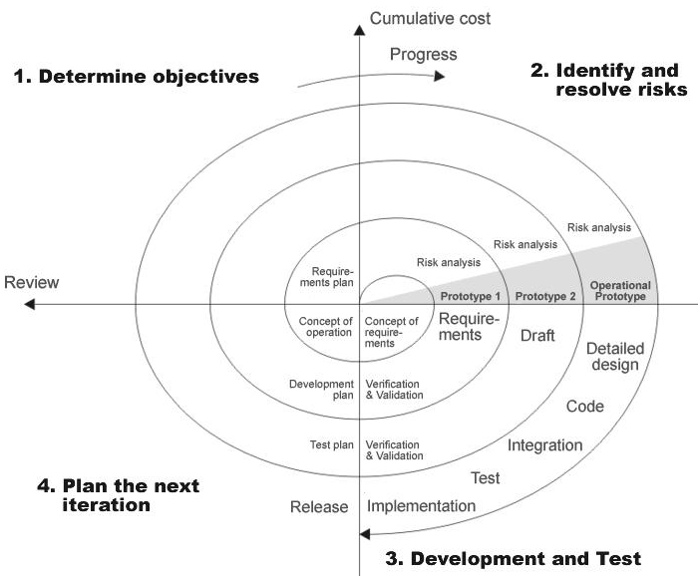

Fig 1.0-Spiral Model

ADVANTAGES:
- Estimates(i.e. budget, schedule etc .) become more relistic as work progresses, because important issues discoved earlier.
- It is more able to cope with the changes that are software development generally entails.
- Software engineers can get their hands in and start woring on the core of a project earlier.

SOFTWARE REQUIREMENT

The software requirement specification can produce at the culmination of the analysis task. The function and performance allocated to software as part of system engineering are refined by established a complete information description, a detailed functional description, a representation of system behavior, an indication of performance and design constrain, appropriate validation criteria, and other information pertinent to requirements. This project requires the following H/W and S/W equipment in order to execute them. They are as given below.

Software Requirements
- Operating System
Windows NT/2000 (Client/Server).
- Software requirements
Java, JDK 1.4, J2SDK 1.4, Swings, RMI and Java Network Programming.

HARDWARE REQUIREMENT

Hardware Requirements:
- System Configuration
Pentium III Processor with 700 MHz Clock Speed
256 MB RAM 20 GB HDD, 32 Bit PCI Ethernet Card.

SYSTEM DESIGN

PROCESS FLOW

DATA FLOW DIAGRAMS

DATA FLOW DIAGRAMS:
A graphical tool used to describe and analyze the moment of data through a system manual or automated including the process, stores of data, and delays in the system. Data Flow Diagrams are the central tool and the basis from which other components are developed. The transformation of data from input to output, through processes, may be described logically and independently of the physical components associated with the system. The DFD is also know as a data flow graph or a bubble chart.
DFDs are the model of the proposed system. They clearly should show the requirements on which the new system should be built. Later during design activity this is taken as the basis for drawing the system’s structure charts. The Basic Notation used to create a DFD’s are as follows:
1. Dataflow: Data move in a specific direction from an origin to a destination.

2. Process: People, procedures, or devices that use or produce (Transform) Data. The physical component is not identified.

3. Source: External sources or destination of data, which may be People, programs, organizations or other entities.

4. Data Store: Here data are stored or referenced by a process in the System.

Compute
the
Histogram
Calculate the IRM
Distance
Image Archive
(Visual Content)
Extract
the
Color feature

Query
Image
Result of the Search

DATA FLOW DIAGRAMS:

Level 0:

Retrieval
System

Query
Image

Result Images

Level 1

Feature
Extraction
Match
And Retrieve
Images

Results
User Query
Our Archive

Level 2
Calculate
IRM
Distance
Query Image
Extract
RGB
Content
Calculate
the
Histogram
Retrieve
the5 best matches
Display
Results
Our Archive

UML Diagrams
Unified Modeling Language:

The Unified Modeling Language allows the software engineer to express an analysis model using the modeling notation that is governed by a set of syntactic semantic and pragmatic rules.

A UML system is represented using five different views that describe the system from distinctly different perspective. Each view is defined by a set of diagram, which is as follows.
  - User Model View
    - This view represents the system from the users perspective.
    - The analysis representation describes a usage scenario from the end-users perspective.

  - Structural model view
    - In this model the data and functionality are arrived from inside the system.
    - This model view models the static structures.

- Behavioral Model View
It represents the dynamic of behavioral as parts of the system, depicting the interactions of collection between various structural elements described in the user model and structural model view.

- Implementation Model View
In this the structural and behavioral as parts of the system are represented as they are to be built.

- Environmental Model View
In this the structural and behavioral aspects of the environment in which the system is to be implemented are represented.

UML is specifically constructed through two different domains they are:
- UML Analysis modeling, this focuses on the user model and structural model views of the system.
- UML design modeling, which focuses on the behavioral modeling, implementation modeling and environmental model views.

Use case Diagrams represent the functionality of the system from a user’s point of view. Use cases are used during requirements elicitation and analysis to represent the functionality of the system. Use cases focus on the behavior of the system from external point of view.

Actors are external entities that interact with the system. Examples of actors include users like administrator, bank customer …etc., or another system like central database.

USE CASE DIAGRAM
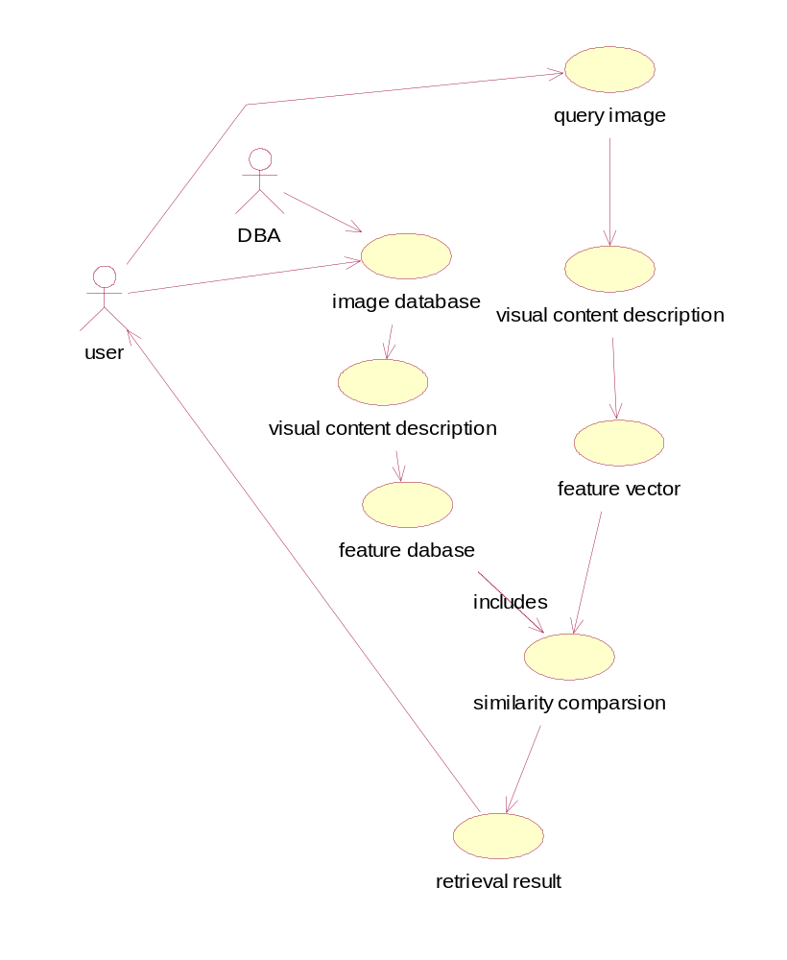

Sequence Diagram:
User:
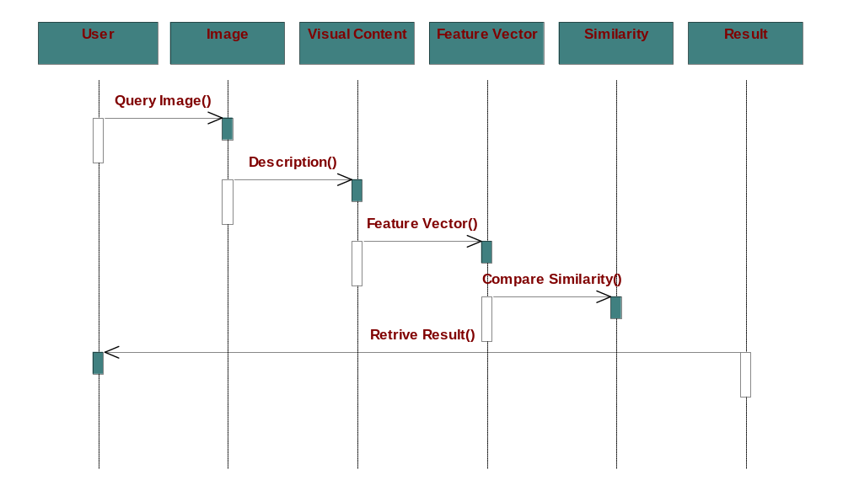

DBA:
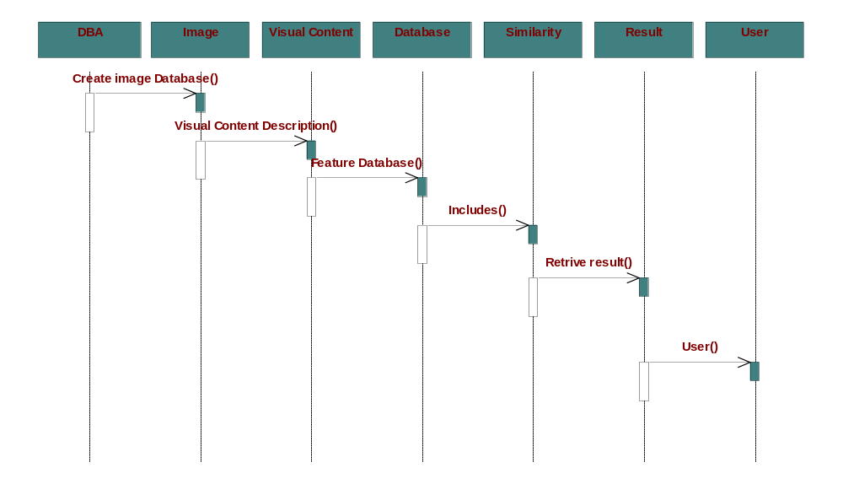

Collaboration Diagram:
User:
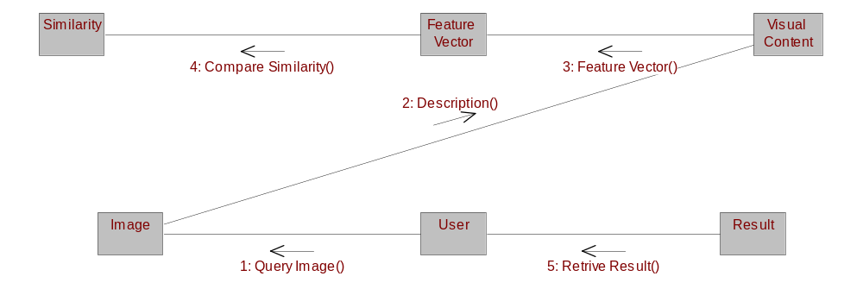

DBA:
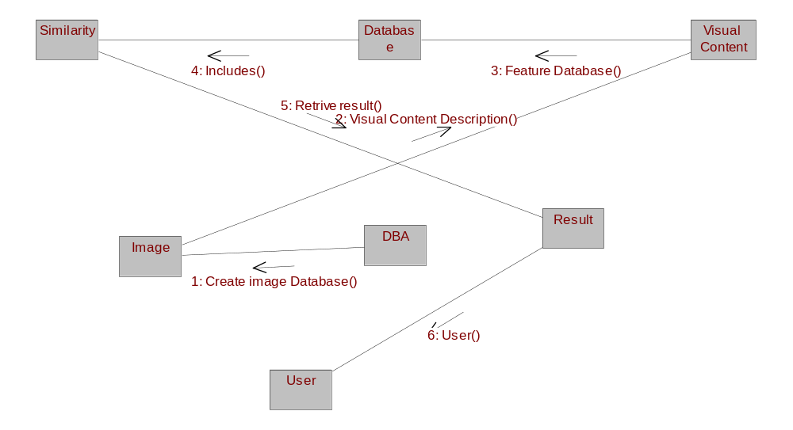

Component Diagram:
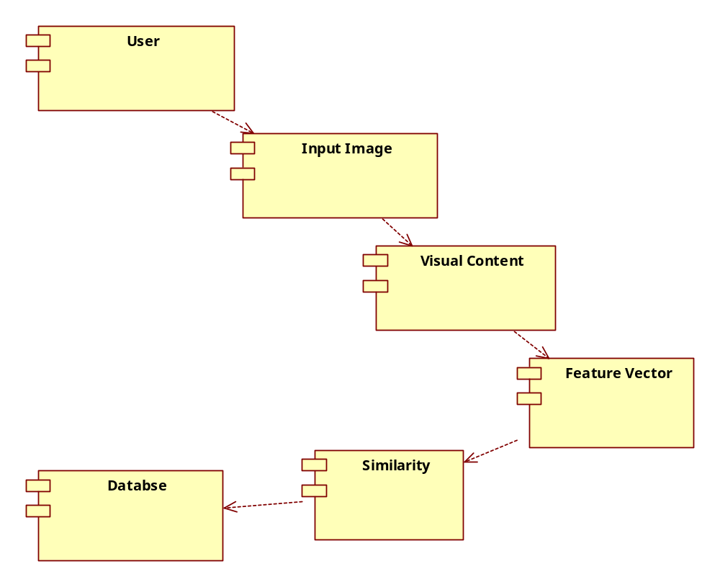

Deployment Diagram:
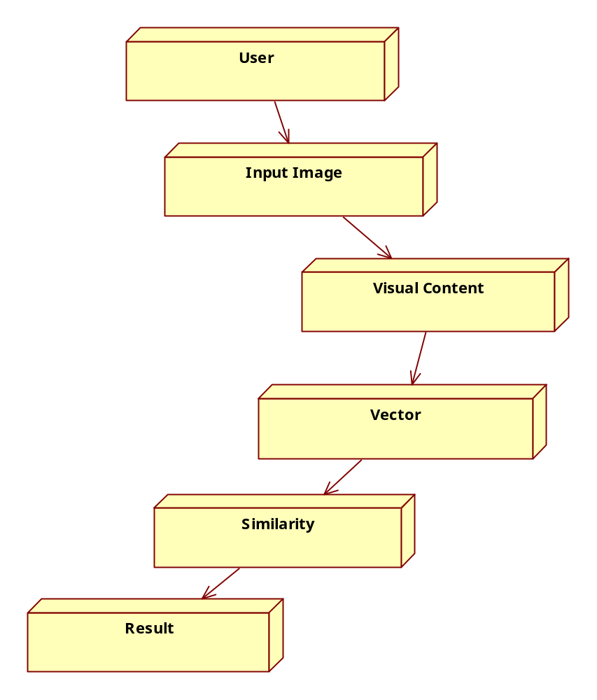

TECHNOLOGY DESCRIPTION

FEATURES OF THE LANGUAGE USED:

About Java:
Initially the language was called as “oak” but it was renamed as “Java” in 1995. The primary motivation of this language was the need for a platform-independent (i.e., architecture neutral) language that could be used to create software to be embedded in various consumer electronic devices.
- Java is a programmer’s language.
- Java is cohesive and consistent.
- Except for those constraints imposed by the Internet environment, Java gives the programmer, full control.
Finally, Java is to Internet programming where C was to system programming.
Swings:
Swing, which is an extension library to the AWT, includes new and improved components that enhance the look and functionality of GUIs. Swing can be used to build Standalone swing Gui Apps as well as Servlets and Applets. It employs a model/view design architecture. Swing is more portable and more flexible than AWT.
Swing is built on top of AWT and is entirely written in Java, using AWT’s lightweight component support. In particular, unlike AWT, t he architecture of Swing components makes it easy to customize both their appearance and behavior. Components from AWT and Swing can be mixed, allowing you to add Swing support to existing AWT-based programs. For example, swing components such as JSlider, JButton and JCheckbox could be used in the same program with standard AWT labels, textfields and scrollbars. You could subclass the existing Swing UI, model, or change listener classes without having to reinvent the entire implementation. Swing also has the ability to replace these objects on-the-fly.
- 100% Java implementation of components
- Pluggable Look & Feel
- Lightweight components
- Uses MVC Architecture
Model represents the data
View as a visual representation of the data
Controller takes input and translates it to changes in data
- Three parts
Component set (subclasses of JComponent)
Support classes
Interfaces
In Swing, classes that represent GUI components have names beginning with the letter J. Some examples are JButton, JLabel, and JSlider. Altogether there are more than 250 new classes and 75 interfaces in Swing — twice as many as in AWT.
Java Swing class hierarchy
The class JComponent, descended directly from Container, is the root class for most of Swing’s user interface components.
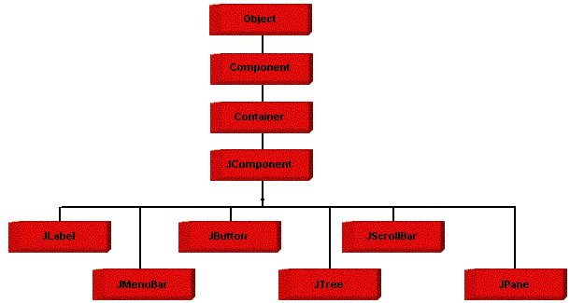
Swing contains components that you’ll use to build a GUI. I am listing you some of the commonly used Swing components. To learn and understand these swing programs, AWT Programming knowledge is not required.

Applications and Applets
An application is a program that runs on our Computer under the operating system of that computer. It is more or less like one creating using C or C++. Java’s ability to create Applets makes it important. An Applet is an application designed, to be transmitted over the Internet and executed by a Java –compatible web browser. An applet is actually a tiny Java program, dynamically downloaded across the network, just like an image. But the difference is, it is an intelligent program, not just a media file. It can react to the user input and dynamically change.

FEATURES OF JAVA:

Security
Every time you that you download a “normal” program, you are risking a viral infection. Prior to Java, most users did not download executable programs frequently, and those who did scanned them for viruses prior to execution. Most users still worried about the possibility of infecting their systems with a virus. In addition, another type of malicious program exists that must be guarded against. This type of program can gather private information, such as credit card numbers, bank account balances, and passwords. Java answers both of these concerns by providing a “firewall” between a networked application and your computer. When you use a Java-compatible Web browser, you can safely download Java applets without fear of virus infection or malicious intent.

Portability
For programs to be dynamically downloaded to all the various types of platforms connected to the Internet, some means of generating portable executable code is needed .As you will see, the same mechanism that helps ensure security also helps create portability. Indeed, Java’s solution to these two problems is both elegant and efficient.

The Byte code
The key that allows the Java to solve the security and portability problem is that the output of Java compiler is Byte code. Byte code is a highly optimized set of instructions designed to execute by the Java run-time system, which is called the Java Virtual Machine (JVM). That is, in its standard form, the JVM is an interpreter for byte code.
Translating a Java program into byte code helps makes it much easier to run a program in a wide variety of environments. The reason is, Once the run-time package exists for a given system, any Java program can run on it.
Although Java was designed for interpretation, there is technically nothing about Java that prevents on-the-fly compilation of byte code into native code. Sun has just completed its Just In Time (JIT) compiler for byte code. When the JIT compiler is a part of JVM, it compiles byte code into executable code in real time, on a piece-by-piece, demand basis. It is not possible to compile an entire Java program into executable code all at once, because Java performs various run-time checks that can be done only at run time. The JIT compiles code, as it is needed, during execution.
Java Virtual Machine (JVM)
Beyond the language, there is the Java virtual machine. The Java virtual machine is an important element of the Java technology. The virtual machine can be embedded within a web browser or an operating system. Once a piece of Java code is loaded onto a machine, it is verified. As part of the loading process, a class loader is invoked and does byte code verification makes sure that the code that’s has been generated by the compiler will not corrupt the machine that it’s loaded on. Byte code verification takes place at the end of the compilation process to make sure that is all accurate and correct. So byte code verification is integral to the compiling and executing of Java code.

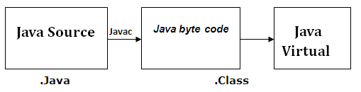

The above picture shows the development process a typical Java programming uses to produce byte codes and executes them. The first box indicates that the Java source code is located in a. Java file that is processed with a Java compiler called JAVA. The Java compiler produces a file called a. class file, which contains the byte code. The class file is then loaded across the network or loaded locally on your machine into the execution environment is the Java virtual machine, which interprets and executes the byte code.

Java Architecture
Java architecture provides a portable, robust, high performing environment for development. Java provides portability by compiling the byte codes for the Java Virtual Machine, which is then interpreted on each platform by the run-time environment. Java is a dynamic system, able to load code when needed from a machine in the same room or across the planet.
Compilation of Code
When you compile the code, the Java compiler creates machine code (called byte code) for a hypothetical machine called Java Virtual Machine (JVM). The JVM is supposed to execute the byte code. The JVM is created for overcoming the issue of portability. The code is written and compiled for one machine and interpreted on all machines. This machine is called Java Virtual Machine.
Compiling and interpreting Java Source Code

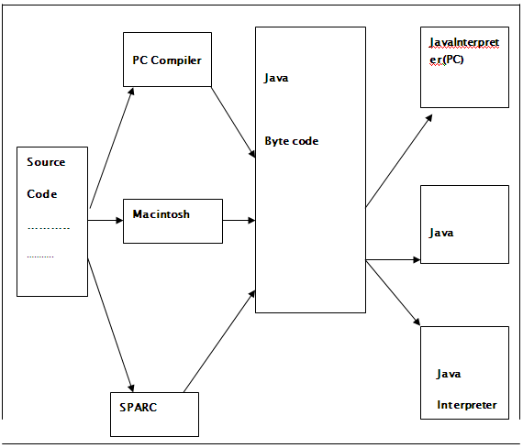
During run-time the Java interpreter tricks the byte code file into thinking that it is running on a Java Virtual Machine. In reality this could be a Intel Pentium Windows 95 or Suns ARC station running Solaris or Apple Macintosh running system and all could receive code from any computer through Internet and run the Applets.

SIMPLE
Java was designed to be easy for the Professional programmer to learn and to use effectively. If you are an experienced C++ programmer, learning Java will be even easier. Because Java inherits the C/C++ syntax and many of the object oriented features of C++. Most of the confusing concepts from C++ are either left out of Java or implemented in a cleaner, more approachable manner. In Java there are a small number of clearly defined ways to accomplish a given task.

Object-Oriented
Java was not designed to be source-code compatible with any other language. This allowed the Java team the freedom to design with a blank slate. One outcome of this was a clean usable, pragmatic approach to objects. The object model in Java is simple and easy to extend, while simple types, such as integers, are kept as high-performance non-objects.

Robust
The multi-platform environment of the Web places extraordinary demands on a program, because the program must execute reliably in a variety of systems. The ability to create robust programs was given a high priority in the design of Java. Java is strictly typed language; it checks your code at compile time and run time. Java virtually eliminates the problems of memory management and de-allocation, which is completely automatic. In a well-written Java program, all run time errors can –and should –be managed by your program.

What is networking?
Computers running on the Internet communicate to each other using either the Transmission Control Protocol (TCP) or the User Datagram Protocol (UDP), as this diagram illustrates:
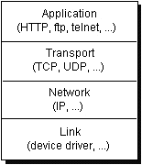
When you write Java programs that communicate over the network, you are programming at the application layer. Typically, you don't need to concern yourself with the TCP and UDP layers. Instead, you can use the classes in the java.net package. These classes provide system-independent network communication. However, to decide which Java classes your programs should use, you do need to understand how TCP and UDP differ.

TCP
When two applications want to communicate to each other reliably, they establish a connection and send data back and forth over that connection. This is analogous to making a telephone call. If you want to speak to Aunt Beatrice in Kentucky, a connection is established when you dial her phone number and she answers. You send data back and forth over the connection by speaking to one another over the phone lines. Like the phone company, TCP guarantees that data sent from one end of the connection actually gets to the other end and in the same order it was sent. Otherwise, an error is reported.
TCP provides a point-to-point channel for applications that require reliable communications. The Hypertext Transfer Protocol (HTTP), File Transfer Protocol (FTP), and Telnet are all examples of applications that require a reliable communication channel. The order in which the data is sent and received over the network is critical to the success of these applications. When HTTP is used to read from a URL, the data must be received in the order in which it was sent. Otherwise, you end up with a jumbled HTML file, a corrupt zip file, or some other invalid information.
Definition: TCP (Transmission Control Protocol) is a connection-based protocol that provides a reliable flow of data between two computers.

UDP
The UDP protocol provides for communication that is not guaranteed between two applications on the network. UDP is not connection-based like TCP. Rather, it sends independent packets of data, called datagrams, from one application to another. Sending datagrams is much like sending a letter through the postal service: The order of delivery is not important and is not guaranteed, and each message is independent of any other.
Definition: UDP (User Datagram Protocol) is a protocol that sends independent packets of data, called datagram’s, from one computer to another with no guarantees about arrival. UDP is not connection-based like TCP.
For many applications, the guarantee of reliability is critical to the success of the transfer of information from one end of the connection to the other. However, other forms of communication don't require such strict standards. In fact, they may be slowed down by the extra overhead or the reliable connection may invalidate the service altogether.
Consider, for example, a clock server that sends the current time to its client when requested to do so. If the client misses a packet, it doesn't really make sense to resend it because the time will be incorrect when the client receives it on the second try. If the client makes two requests and receives packets from the server out of order, it doesn't really matter because the client can figure out that the packets are out of order and make another request. The reliability of TCP is unnecessary in this instance because it causes performance degradation and may hinder the usefulness of the service.
Another example of a service that doesn't need the guarantee of a reliable channel is the ping command. The purpose of the ping command is to test the communication between two programs over the network. In fact, ping needs to know about dropped or out-of-order packets to determine how good or bad the connection is. A reliable channel would invalidate this service altogether.
The UDP protocol provides for communication that is not guaranteed between two applications on the network. UDP is not connection-based like TCP. Rather, it sends independent packets of data from one application to another. Sending datagrams is much like sending a letter through the mail service: The order of delivery is not important and is not guaranteed, and each message is independent of any others.
Note: Many firewalls and routers have been configured not to allow UDP packets. If you're having trouble connecting to a service outside your firewall, or if clients are having trouble connecting to your service, ask your system administrator if UDP is permitted.

Understanding Ports
Generally speaking, a computer has a single physical connection to the network. All data destined for a particular computer arrives through that connection. However, the data may be intended for different applications running on the computer. So how does the computer know to which application to forward the data? Through the use of ports.
Data transmitted over the Internet is accompanied by addressing information that identifies the computer and the port for which it is destined. The computer is identified by its 32-bit IP address, which IP uses to deliver data to the right computer on the network. Ports are identified by a 16-bit number, which TCP and UDP use to deliver the data to the right application.
In connection-based communication such as TCP, a server application binds a socket to a specific port number. This has the effect of registering the server with the system to receive all data destined for that port. A client can then rendezvous with the server at the server's port, as illustrated here:
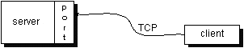
Definition: The TCP and UDP protocols use ports to map incoming data to a particular process running on a computer.
In datagram-based communication such as UDP, the datagram packet contains the port number of its destination and UDP routes the packet to the appropriate application, as illustrated in this figure:
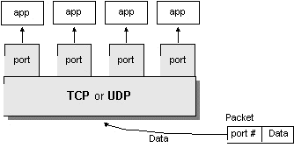
Port numbers range from 0 to 65,535 because ports are represented by 16-bit numbers. The port numbers ranging from 0 - 1023 are restricted; they are reserved for use by well-known services such as HTTP and FTP and other system services. These ports are called well-known ports. Your applications should not attempt to bind to them.

Networking Classes in the JDK
Through the classes in java.net, Java programs can use TCP or UDP to communicate over the Internet. The URL, URL Connection, Socket, and Server Socket classes all use TCP to communicate over the network. The Datagram Packet, Datagram Socket, and Multicast Socket classes are for use with UDP.

What Is a URL?
If you've been surfing the Web, you have undoubtedly heard the term URL and have used URLs to access HTML pages from the Web.
It's often easiest, although not entirely accurate, to think of a URL as the name of a file on the World Wide Web because most URLs refer to a file on some machine on the network. However, remember that URLs also can point to other resources on the network, such as database queries and command output.
Definition: URL is an acronym for Uniform Resource Locator and is a reference (an address) to a resource on the Internet.
The following is an example of a URL which addresses the Java Web site hosted by Sun Microsystems:
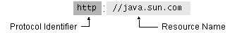
As in the previous diagram, a URL has two main components:
- Protocol identifier
- Resource name
Note that the protocol identifier and the resource name are separated by a colon and two forward slashes. The protocol identifier indicates the name of the protocol to be used to fetch the resource. The example uses the Hypertext Transfer Protocol (HTTP), which is typically used to serve up hypertext documents. HTTP is just one of many different protocols used to access different types of resources on the net. Other protocols include File Transfer Protocol (FTP), Gopher, File, and News.
The resource name is the complete address to the resource. The format of the resource name depends entirely on the protocol used, but for many protocols, including HTTP, the resource name contains one or more of the components listed in the following table:

Host Name | The name of the machine on which the resource lives.
Filename | The pathname to the file on the machine.
Port Number | The port number to which to connect (typically optional).
Reference | A reference to a named anchor within a resource that usually identifies a specific location within a file (typically optional).
For many protocols, the host name and the filename are required, while the port number and reference are optional. For example, the resource name for an HTTP URL must specify a server on the network (Host Name) and the path to the document on that machine (Filename); it also can specify a port number and a reference. In the URL for the Java Web site java.sun.com is the host name and the trailing slash is shorthand for the file named /index.html.
Sequence of socket calls for connection-oriented protocol:

System Calls
Socket - create a descriptor for use in network communication. On success, socket system call returns a small integer value similar to a file descriptor Name.

Bind - Bind a local IP address and protocol port to a socket
When a socket is created it does not have nay notion of endpoint address. An application calls bind to specify the local; endpoint address in a socket. For TCP/IP protocols, the endpoint address uses the socket address in structure. Servers use bind to specify the well-known port at which they will await connections.

Connect - connect to remote client
After creating a socket, a client calls connect to establish an actual connection to a remote server. An argument to connect allows the client to specify the remote endpoint, which include the remote machines IP address and protocols port number. Once a connection has been made, a client can transfer data across it.

Accept () - accept the next incoming connection
Accept creates a new socket for each new connection request and returns the descriptor of the new socket to its caller. The server uses the new socket only for the new connections it uses the original socket to accept additional connection requests once it has accepted connection, the server can transfer data on the new socket.
Return Value:
This system-call returns up to three values
An integer return code that is either an error indication or a new socket description
The address of the client process
The size of this address
Listen - place the socket in passive mode and set the number of incoming TCP connections the system will en-queue. Backlog - specifies how many connections requests can be queued by the system while it wants for the server to execute the accept system call it us usually executed after both the socket and bind system calls, and immediately before the accept system call.
Send, send to, recv and recvfrom system calls
These system calls are similar to the standard read and write system calls, but additional arguments are requested.
Close - terminate communication and de-allocate a descriptor. The normal UNIX close system call is also used to close a socket.

CODING
Display:

/* <html>
<body>
<applet code="display.class" height=600 width=1200>
<param name ="imgn" value = "C:\\irmproject\\irmfinal2\\12.jpg">

</applet>
</body>
</html>*/

import java.applet.Applet;
import java.awt.*;
import java.awt.event.*;
import java.awt.image.*;
import java.io.*;
import java.lang.Math;
import java.applet.*;

class histogram implements Serializable
{
public int imgno;
public String imgname;
public float[][] he1=new float[256][4];
public histogram(){}
}

public class display extends Applet implements Runnable
{
private Thread imageThread = null;
private Image imagetoDisplay;
private Image imageArray[];
private int noimgs = 6,currentimg=0,sleeptime=1000;
float[][] w2=new float[99][2];

Image rawimg1;
int imgcols1,imgrows1;
MediaTracker tracker1;
int[] pix1;
int[][][] pix3;
float[][] hes=new float[256][4];
float[][] hes1=new float[256][4];
float w1=0,w3;
int fileno=1;
static int n=1;
int l=10,k=10,m=0;
Image img1;
static String str1,str4,str11,strn1,strn2,strn,strn0;
int x,y;

public void init()

{

/*setLayout(new BorderLayout());
Panel p=new Panel();
TextField tf1=new TextField(30);
Button b1=new Button("Browse");
Button b2=new Button("Search");
//b1.addActionListener(new ButtonHandler());
//b2.addActionListener(new ButtonHandler());
p.add(tf1);
p.add(b1);
p.add(b2);
add("South",p);*/
try
{
str1 = getParameter("imgn");
input123(str1);

for(int i=1;i<=94;i++)
{
System.out.println("image no: "+w2[i][0]+"irm distance:"+w2[i][1]);
}

for(int i=1;i<94;i++)
{
for(int j=1;j<94-i-1;j++)
{
if(w2[j][1]>w2[j+1][1])
{
float k=w2[j+1][1];
float k1=w2[j+1][0];
w2[j+1][1]=w2[j][1];
w2[j][1]=k;
w2[j+1][0]=w2[j][0];
w2[j][0]=k1;
}
}
}

imageArray = new Image[noimgs];
int j=0;
String str,strn,strn1;

for(int i=1;i<imageArray.length;i++)
{
strn=""+w2[i][0];
int x=strn.indexOf('.');
strn1=strn.substring(0,x);
str=strn1+".jpg";
System.out.println(str);
imageArray[i] = getImage(getDocumentBase(),str);
}
imageThread = new Thread(this);
imageThread.start();
}catch(Exception e){};
x=0;y=0;
}

public void start()
{
imageThread.resume();
}

public void suspend()
{
imageThread.suspend();
}

public void destroy()
{
//imageThread.stop();
}

public void run()
{
for(int i=1;i<imageArray.length;i++)
{
imagetoDisplay = imageArray[i];
try
{
imageThread.sleep(1000);
}
catch(Exception e){}
}
}

public void paint(Graphics g)
{
for(int i=0;i<imageArray.length;i++)
{
imagetoDisplay = imageArray[i];
if(imagetoDisplay != null)
g.drawImage(imagetoDisplay,0+i*150,0,150,150,this);
}
}

public void input123(String s)
{
try
{

//creating image object
System.out.println("processing"+s);
rawimg1=Toolkit.getDefaultToolkit().getImage(s);
tracker1= new MediaTracker(this);
tracker1.addImage(rawimg1,1);

//checking the image is loaded or not
try
{
if(!tracker1.waitForID(1,10000))
{
System.out.println("load error");
System.exit(1);
}
}
catch(Exception e)
{
e.printStackTrace();
System.exit(1);
}

//checking whether all the pixels are loaded of not
if((tracker1.statusAll(false)&MediaTracker.ERRORED&MediaTracker.ABORTED)!=0)
{
System.out.println("Load error");
System.exit(1);
}

imgcols1=rawimg1.getWidth(this);
imgrows1=rawimg1.getHeight(this);

//grabbing pixels into the array
pix1=new int[imgcols1*imgrows1];
try
{
PixelGrabber pgobj=new PixelGrabber(rawimg1,0,0,imgcols1,imgrows1,pix1,0,imgcols1);
pgobj.grabPixels();
}
catch(Exception e)
{
}

//converting the 1D pixel data to 3D data
pix3=new int[imgrows1][imgcols1][4];

for(int row=0;row<imgrows1;row++)
{
int[] aRow=new int[imgcols1];
for(int col=0;col<imgcols1;col++)
{
int element=row*imgcols1+col;
aRow[col]=pix1[element];
}
for(int col=0;col<imgcols1;col++)
{
pix3[row][col][0]=(aRow[col]>>24)&0xFF;
pix3[row][col][1]=(aRow[col]>>16)&0xFF;
pix3[row][col][2]=(aRow[col]>>8)&0xFF;
pix3[row][col][3]=(aRow[col])&0xFF;
}
}

int tt1=imgrows1*imgcols1;

for(int i=0;i<256;i++)
for(int j=0;j<4;j++)
hes[i][j]=0;

for(int i=0;i<imgrows1;i++)
{
for(int j=0;j<imgcols1;j++)
{
for(int k=1;k<4;k++)
{
int l=pix3[i][j][k];
hes[l][k]=hes[l][k]+1;
}
}
}
for(int i=0;i<256;i++)
{
for(int j=1;j<4;j++)
{
hes[i][j]=hes[i][j]/tt1;
}
}

//reading from the histogram file
histogram hist = new histogram();

for(int k=1;k<=94;k++)
{

for(int i=0;i<256;i++)
{
for(int j=1;j<4;j++)
{
hes1[i][j]=hes[i][j];
}
}

FileInputStream fis = new FileInputStream("C:\\irmproject\\irmfinal2\\histogram"+k+".dat");
ObjectInputStream ois = new ObjectInputStream(fis);
hist=(histogram)ois.readObject();

int[][] f1=new int[256][256];
int[] temp1=new int[256];
int[] t1=new int[256];
int[] t2=new int[256];

System.out.println("reading image no:"+hist.imgno+"image name:"+hist.imgname);

for(int i=0;i<256;i++)
{
temp1[i]=i;
t2[i]=0;
t1[i]=0;
}

for(int i=0;i<256;i++)
{
for(int j=0;j<256;j++)
{
f1[i][j]=Math.abs(temp1[i]-temp1[j]);
}
}

for(int l=0;l<256;l++)
{
for(int i=0;i<256;i++)
{
for(int j=0;j<256;j++)
{
if(f1[i][j]==l&&t1[i]==0&&t2[j]==0)
{
float l1,l2;
l1=hes1[i][1];
l2=hist.he1[j][1];
if(l1<l2)
{
w1=w1+l*l1;
hes1[i][1]=0;
t1[i]=1;
hist.he1[j][1]=l2-l1;
}

if(l1>l2)
{
w1=w1+l*l2;
hes1[i][1]=l1-l2;
t2[j]=1;
hist.he1[j][1]=0;
}

if(l1==l2)
{
w1=w1+l*l1;
hes1[i][1]=0;
t1[i]=1;
t2[j]=1;
hist.he1[j][1]=0;
}
}
}
}
}

for(int i=0;i<255;i++)
{
t1[i]=0;
t2[i]=0;
}

for(int l=0;l<255;l++)
{
for(int i=0;i<255;i++)
{
for(int j=0;j<255;j++)
{
if(f1[i][j]==l&&t1[i]==0&&t2[j]==0)
{
float l1,l2;
l1=hes1[i][2];
l2=hist.he1[j][2];
if(l1<l2)
{
w1=w1+l*l1;
hes1[i][2]=0;
t1[i]=1;
hist.he1[j][2]=l2-l1;
}

if(l1>l2)
{
w1=w1+l*l2;
hes1[i][2]=l1-l2;
t2[j]=1;
hist.he1[j][2]=0;
}

if(l1==l2)
{
w1=w1+l*l1;
hes1[i][2]=0;
t1[i]=1;
t2[j]=1;
hist.he1[j][2]=0;
}
}
}
}
}

for(int i=0;i<255;i++)
{
t1[i]=0;
t2[i]=0;
}

for(int l=0;l<255;l++)
{
for(int i=0;i<255;i++)
{
for(int j=0;j<255;j++)
{
if(f1[i][j]==l&&t1[i]==0&&t2[j]==0)
{
float l1,l2;
l1=hes1[i][3];
l2=hist.he1[j][3];
if(l1<l2)
{
w1=w1+l*l1;
hes1[i][3]=0;
t1[i]=1;
hist.he1[j][3]=l2-l1;
}

if(l1>l2)
{
w1=w1+l*l2;
hes1[i][3]=l1-l2;
t2[j]=1;
hist.he1[j][3]=0;
}

if(l1==l2)
{
w1=w1+l*l1;
hes1[i][3]=0;
t1[i]=1;
t2[j]=1;
hist.he1[j][3]=0;
}
}
}
}
}
System.out.println("distance for this image is:"+w1);
w2[k][0]=k;
w2[k][1]=w1;
w1=0;
ois.close();
fis.close();
}
}catch(Exception e2){System.out.println(e2);}
}
/* class ButtonHandler implements ActionListener
{
public void actionPerformed(actionEvent e)
{
String s=e.getActionCommand();
if("Browse".equals(s))
{

}
}
}*/

}

TESTING

Testing Concepts

- Testing

- Testing Methodologies

- Black box Testing:
- White box Testing.
- Gray Box Testing.

- Levels of Testing

  - Unit Testing.
  - Module Testing.
  - Integration Testing.
  - System Testing.
  - User Acceptance Testing.

- Types Of Testing

  - Smoke Testing.
  - Sanitary Testing.
  - Regression Testing.
  - Re-Testing.
  - Static Testing.
  - Dynamic Testing.
  - Alpha-Testing.
  - Beta-Testing.
  - Monkey Testing.
  - Compatibility Testing.
  - Installation Testing.
  - Adhoc Testing.
  - Ext….

TCD (Test Case Documentation)

- STLC
  - Test Planning.
  - Test Development.
  - Test Execution.
  - Result Analysis.
  - Bug-Tracing.
  - Reporting.

- Microsoft Windows – Standards
- Manual Testing
- Automation Testing (Tools)
  - Win Runner.
  - Test Director.

Testing:

- The process of executing a system with the intent of finding an error.
- Testing is defined as the process in which defects are identified, isolated, subjected for rectification and ensured that product is defect free in order to produce the quality product and hence customer satisfaction.
- Quality is defined as justification of the requirements
- Defect is nothing but deviation from the requirements
- Defect is nothing but bug.
- Testing --- The presence of bugs
- Testing can demonstrate the presence of bugs, but not their absence
- Debugging and Testing are not the same thing!
- Testing is a systematic attempt to break a program or the AUT
- Debugging is the art or method of uncovering why the script /program did not execute properly.

Testing Methodologies:

- Black box Testing: is the testing process in which tester can perform testing on an application without having any internal structural knowledge of application.
Usually Test Engineers are involved in the black box testing.
- White box Testing: is the testing process in which tester can perform testing on an application with having internal structural knowledge.
Usually The Developers are involved in white box testing.

- Gray Box Testing: is the process in which the combination of black box and white box tonics’ are used.

Levels of Testing:

Module1 Module2 Module3
Units |  | Units |  | Units
i/p Integration o/p i/p Integration o/p

System Testing: Presentation + business +Databases
UAT: user acceptance testing

STLC (SOFTWARE TESTING LIFE CYCLE)

Test Planning:
1.Test Plan is defined as a strategic document which describes the procedure how to perform various testing on the total application in the most efficient way.
2.This document involves the scope of testing,
3. Objective of testing,
4. Areas that need to be tested,
5. Areas that should not be tested,
6. Scheduling Resource Planning,
7. Areas to be automated, various testing tools
Used….

Test Development:
1. Test case Development (check list)
2. Test Procedure preparation. (Description of the Test cases).
1. Implementation of test cases. Observing the result.

Result Analysis: 1. Expected value: is nothing but expected behavior
Of application.
2. Actual value: is nothing but actual behavior of
application
Bug Tracing: Collect all the failed cases, prepare documents.

Reporting: Prepare document (status of the application)

Types Of Testing:

> Smoke Testing: is the process of initial testing in which tester looks for the availability of all the functionality of the application in order to perform detailed testing on them. (Main check is for available forms)

> Sanity Testing: is a type of testing that is conducted on an application initially to check for the proper behavior of an application that is to check all the functionality are available before the detailed testing is conducted by on them.

> Regression Testing: is one of the best and important testing. Regression testing is the process in which the functionality, which is already tested before, is once again tested whenever some new change is added in order to check whether the existing functionality remains same.

>Re-Testing: is the process in which testing is performed on some functionality which is already tested before to make sure that the defects are reproducible and to rule out the environments issues if at all any defects are there.

Static Testing: is the testing, which is performed on an application when it is not been executed.ex: GUI, Document Testing

Dynamic Testing: is the testing which is performed on an application when it is being executed.ex: Functional testing.

Alpha Testing: it is a type of user acceptance testing, which is conducted on an application when it is just before released to the customer.

 Beta-Testing: it is a type of UAT that is conducted on an application when it is released to the customer, when deployed in to the real time environment and being accessed by the real time users.

 Monkey Testing: is the process in which abnormal operations, beyond capacity operations are done on the application to check the stability of it in spite of the users abnormal behavior.

Compatibility testing: it is the testing process in which usually the products are tested on the environments with different combinations of databases (application servers, browsers…etc) In order to check how far the product is compatible with all these environments platform combination.

Installation Testing: it is the process of testing in which the tester try to install or try to deploy the module into the corresponding environment by following the guidelines produced in the deployment document and check whether the installation is successful or not.

Adhoc Testing: Adhoc Testing is the process of testing in which unlike the formal testing where in test case document is used, with out that test case document testing can be done of an application, to cover that testing of the future which are not covered in that test case document. Also it is intended to perform GUI testing which may involve the cosmotic issues.

TCD (Test Case Document):

Test Case Document Contains

- Test Scope (or) Test objective
- Test Scenario
- Test Procedure
- Test case
This is the sample test case document for the Case Investigate details of Client project:

Test scope:

- Test coverage is provided for the screen “ Login check” form of a Administration module of Forensic Manager application
- Areas of the application to be tested

Test Scenario:

- When the office personals use this screen for the data entry, adding sections, courts, grades and Case Registration information on s basis and quit the form.

Test Procedure:

- The procedure for testing this screen is planned in such a way that the data entry, status calculation functionality, saving and quitting operations are tested in terms of GUI testing, Positive testing, Negative testing using the corresponding GUI test cases, Positive test cases, Negative test cases respectively

Test Cases:

- Template for Test Case

T.C.No | Description | Exp | Act | Result

Guidelines for Test Cases:

- GUI Test Cases:

- Total no of features that need to be check
- Look & Feel
- Look for Default values if at all any (date & Time, if at all any require)
- Look for spell check

Example for Gui Test cases:

T.C.No | Description | Expected value | Actual value | Result
1 | Check for all the features in the screen | The screen must contain all the features
2 | Check for the alignment of the objects as per the validations | The alignment should be in proper way

- Positive Test Cases:

- The positive flow of the functionality must be considered
- Valid inputs must be used for testing
- Must have the positive perception to verify whether the requirements are justified.

- Positive Test Cases:

- The positive flow of the functionality must be considered
- Valid inputs must be used for testing
- Must have the positive perception to verify whether the requirements are justified.

Example for Positive Test cases:

T.C.No | Description | Expected value | Actual value | Result
1 | Input UserName and Password | Redirect to HomePage | Redirect to Home Page | Redirect to Home Page
2

- Negative Test Cases:

- Must have negative perception.
- Invalid inputs must be used for test.

Example for Negative Test cases:
T.C.No | Description | Expected value | Actual value | Result
1 | Input username and password | Login Page | Login Page | Login Page
2

SCREENS

Input (or) Query Image:

Images retrieved from the Database:

5 matches out of 5

Input (or) Query Image:

Images retrieved from the Database:

5 matches out of 5

FUTURE ENHANCEMENTS:
It is not possible to develop a system that makes all the requirements of the user. User requirements keep changing as the system is being used. Some of the future enhancements that can be done to this system are:
- As the technology emerges, it is possible to upgrade the system and can be adaptable to desired environment.
- Because it is based on object-oriented design, any further changes can be easily adaptable.
- Based on the future security issues, security can be improved using emerging technologies.

BIBLIOGRAPHY

REFERENCES
(1) Java Complete Reference By Herbert Shield
(2) Database Programming with JDBC and Java By George Reese
(3) Java and XML By Brett McLaughlin

(4) Wikipedia, URL: http://www.wikipedia.org.

(5) Answers.com, Online Dictionary, Encyclopedia and much more, URL: http://www.answers.com
(6) Google, URL: http://www.google.co.in
(7)Project Management URL: http://www.startwright.com/project.htm
(8) http://it.toolbLox.com/wiki/index.php/Warehouse_Management

